3.1. 004000

3.2. The next instruction. Because the current instruction is processed in the int Regs (which is colored red)

3.3.

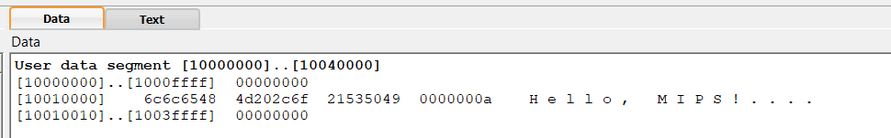

3.4.

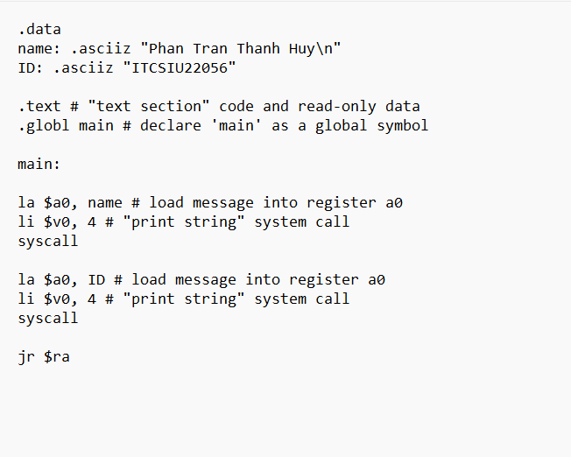

4.3.

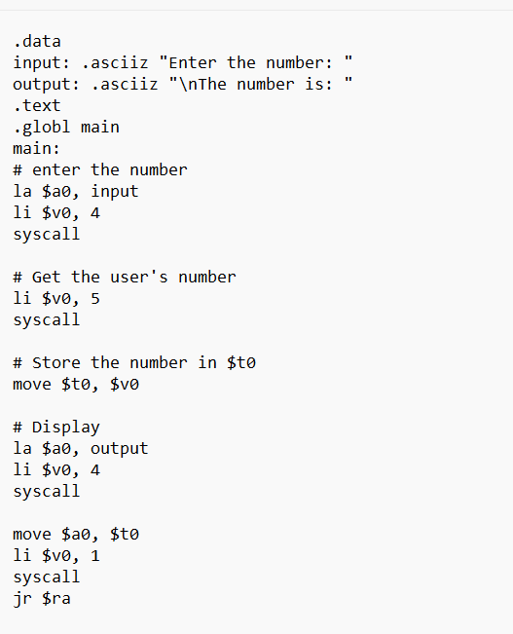

4.4.